Notes on the Abandoned Jewish Cemetery in Szirák
GPS Coordinates 47°49'59.0"N 19°31'29.0"E (from Google Earth)
Report compiled May 2015 by Roy Grant, residing in the nearby village of Bér.
Introduction and Site Report

The village of Szirák in the Hungarian county of Nógrád, was once a thriving community, but that is no longer the case. The richness of its glorious chateau now seems out of place when compared with some other properties in the area. Whilst there have been a few holiday home conversions, these are overshadowed by an abundance of poorly maintained properties, some reaching the stage where they are still lived in, but are clearly well beyond economic repair.

Without knowing where to look on Google Earth (see GPS Coordinates above) Szirák’s abandoned Jewish cemetery is not obvious. It lies to the north of the village and no longer has a gate or a surrounding fence. A wide lane beside the Lutheran church should be the best way to approach its remote location, but that lane becomes almost impassable during the late spring until winter and anything smaller than a large headstone disappears beneath a cover of wild vegetation. Fortunately the approach lane and cemetery were recently cleared of major obstructions, revealing the extent of devastation, but also giving a brief seasonal window of opportunity to make a record of the site. *

The cemetery has no evidence of any post WW2 burials so it is assumed the events of those times caused it to fall into disuse leaving no one to care for it. Nature then reclaimed the site, covering it with bushes and trees which obscured epitaphs and caused horrendous damage. My visit in March revealed that it still has a few of the heavier polished markers, but lacks any reverence and looks robbed out. There is no longer any visual evidence of anything metallic or sculptured and there are noticeable unmarked gaps where there may have previously been additional burials. Of about 100 surviving headstones, just over half are still standing. Some appear to have sunk, others have fallen and either separated into their component parts or broken up completely. Several lie partially buried face down in the soil giving no idea to whom they referred, or where they may have originally stood. One small headstone also lies embedded in the track of the lane nearby. Their inscriptions (a mix of Hebrew and Hungarian) are often heavily worn so vary greatly in legibility.
No detailed map seems to exist and graves appear to occupy random positions on the undulating hillside following no obvious date sequence with their immediate neighbours. The only straight line of surviving headstones is that that abuts the lane that passes on the western side of the cemetery. Progressing inwards, any semblance of that straight line dissolves as the headstones become less frequent and begin to merge with the far more weathered random stones from earlier in time.

Although this brief record of my findings divides the cemetery into upper and lower sections and presents the results as two simple grids, the terrain is such that it cannot be truly representative of the actual site conditions. One problem is that there are areas where the burials are not tightly grouped and there are a number of isolated stones some distance away on the cemetery apron. Furthermore, the smaller lower section of the cemetery includes a rectangular patch of rubble which may have once been a small chapel or vault, but no structural stonework remains to verify either.

Amongst the headstones in the lower section are also the foundations of what appear to have been larger plots used for family burials. The remains of some of these are quite substantial suggesting they once supported decorative sculptures, but it is assumed that without cemetery supervision, any adornments were removed by ‘collectors’ wishing to capitalise on their monetary value. This area also contains toppled obelisks, but as elsewhere on the site, determining their component parts and original positions is speculative rather than factual.

I have passed a copy of this report accompanied by my collection of photographs to:
NOGR - International Jewish Cemetery Project who aim to catalogue every Jewish burial site. (www.iajgsjewishcemeteryproject.org › Eastern Europe › Hungary)
To facilitate their transcription of the Hebrew texts on some of the later headstones, I have also included a series of photographs and my précis of those Jewish burials entered into the local registers between 1895-1945, which I abstracted from the State Archives. Hopefully the expertise NOGR and their knowledge of Hebrew script will augment my findings and provide a more informative permanent record of the abandoned Jewish Cemetery in Szirák, Nógrád, Hungary.

*I regret I have been unable to fully adhere to the NOGR requirements for my return visit to fine tune my findings had to be aborted because in a matter of only a few weeks nature had taken back control

Two Cemetery Photos (taken when the site was clear in April 2015)

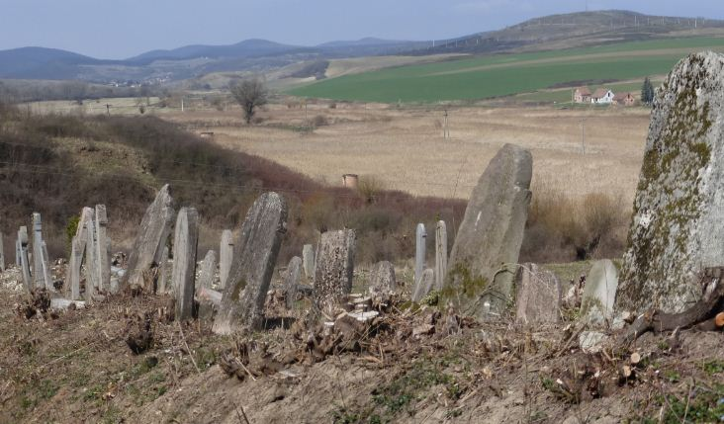
The cemetery is on the right hand side of the approach lane.
In the distance are the village of Bér and the Cserhát Hills

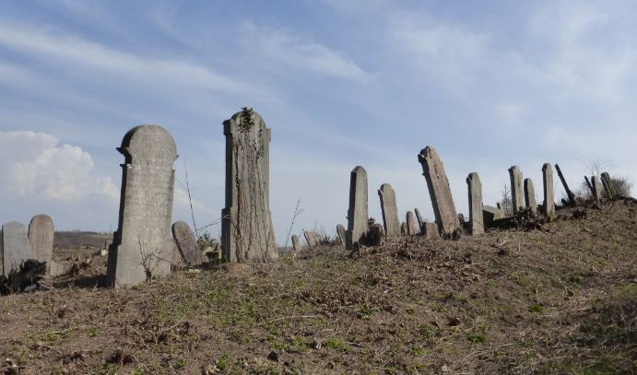
The lane in April with the cemetery to the left.

Opposite is the same lane 6 weeks later (May)
It is obvious that nature wastes no time
regaining its stranglehold on the cemetery.

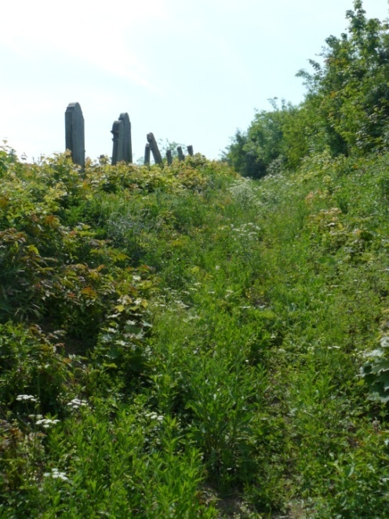

GOOGLE EARTH PICTURES showing the cemetery location

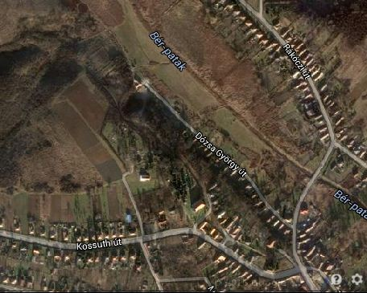

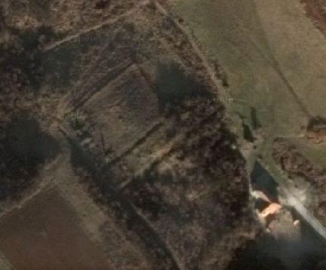
Enlargement of the relevant section of the above aerial view

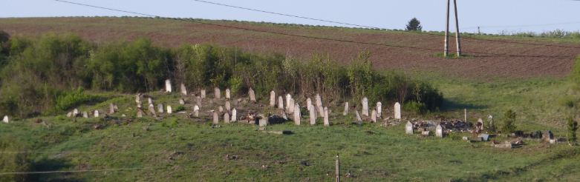
Panoramic view of the entire Jewish Cemetery,
With an arrow inserted to show my suggested division between the upper and lower areas

Rough positions of surviving headstones in the upper part of the cemetery

K | J | I | H | G | Row  F | Row E | Row  D | Row  C | Row  B | Row  A | Path
 | X |  |  |  |  | X |  | X |  | X Hebrew | 1
 |  |  |  |  | X |  |  | X |  | X Hebrew | 2
 |  |  |  |  |  | X |  |  | X | In 2 halves | 3
X |  |  | X |  |  | X |  |  |  | X | 4
 |  |  | X |  | X | X |  |  | X | Hasenfeld Esther | 5
X |  | X |  |  | X | X |  | X | X | Hasenfeld Arnold | 6
 |  | X |  |  |  |  | Jozef Markoviz |  |  |  | 7
 |  | X |  |  |  |  | Rezi Lederer |  |  | Buchwalder Abraham | 8
 |  | X |  |  |  |  | X | X | X | X | 9
 |  |  |  |  | X |  |  |  |  | Frankl Ahron & Anna nee Brüll | 10
 |  |  |  |  |  | X |  |  |  | Brüll Fani  nee Simon | 11
 |  |  |  |  | Muller Lipot |  |  |  | Arnstein Bertha | Brüll Izsak | 12
 |  |  |  |  | Triple | Plot | Freidman Herman |  | Buchwalder Rozalia |  | 13
 |  |  |  |  | Triple | Plot | Martha Freidman |  | X | X Fallen | 14
 |  |  |  |  | Triple | Plot |  |  | Weiner Terez | Buchwalder Hani nee Spitzer | 15
 |  |  | Schon |  |  |  | X | X |  | X | 16
 |  |  | Schon |  |  |  | X |  |  | X Fallen | 17
 |  |  |  |  |  |  |  | X | Deutsch Katalin | X Fallen | 18
 |  |  |  |  |  |  |  |  |  | Szepesi Adolf | 19
 |  |  |  |  | Gutfreund  Abraham |  |  |  |  | Hasenfeld Benjamin | 20
 |  |  |  |  | Gutfruend  Katalin |  |  |  | Hasenfeld Adolf | Hasenfeld Lina | 21
 |  |  |  |  | Spielberge  Ignacz |  |  |  | Wm Farkas | Deutsch | 22
 |  |  |  |  |  |  |  |  | Farkas /Low |  | 23
 |  |  |  |  |  |  |  |  |  | Possible chapel

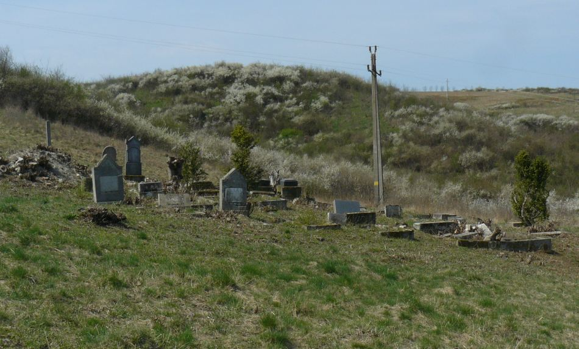

A rough grid showing burials in the lower part of the cemetery

Row D | Row C | Row B | Row A | Lane
 |  | Steiner Gyuri | Foundations of a Vault or Chapel?
 |  |  | X | 01
Gottlieb Miksane | X |  | David Kohn  Photo | 02
 | Frisch Fani |  |  | 03
Bernfeld Zsuzsa | Wiener? Arnold |  | Quad plot | 04
 |  | Double | Quad plot | 05
Gottlieb Miksa | X | plot | Quad plot | 06
 |  |  | Quad plot | 07
X |  | X | X | 08
 |  | X | X | 09
Markusz Mika |  |  |  | 10
 |  | X |  | 11
 |  |  |  | 12
Guttenberg Erzsébet  & others |  |  | A collection of fallen obelisks and markers from the area | 13  14  15
 |  |  |  | 16
X |  |  |  | 17

Numerous photographs taken at various intervals will be sent separately by snail mail on a CD. Regrettably there are many duplications because my return visit to fine tune earlier findings had to be aborted due to the present condition of the site. My apologies, it may take some sorting, but I hope you can get everything you need from the illustrations. If I can sort any arising problems from my notes, I will happily do so, otherwise I will have to wait to March of next year for a return visit.
An alphabetical listing of those names written on the headstones in Hungarian

Marker’s  approximate row/number | Photo ref no. | Name  and name of parent  and/or maiden name of spouse | Born  Circa | Age | Died
B-12 | 207 | Arnstein Bertha | 1862 | 12 | Dec 1874
Lower Cem | 055 | Bernfeld Zsuzsika | 1922 | 13 | 17 Sep 1935
A- | 214 | Biedermann Ignácz | 1850 | 62 | 11 Apr 1912
A-11 | 236 + 237 | Brüll Fani nee Simon (Dual sided stone) | 1812 | 60 | 1872
A-12 | 234 + 235 | Brüll Izsak (Dual sided stone) | 1816 | 62 | 17 June 1878
A-08 | 808+ 119 | Buchwalder Abraham (stone in fragments) | 1857 | 28 | 1863
A-15 | 07-822 | Buchwalder Hani nee Spitzer |  |  | 1878
B-13 | 200 + 201 | Buchwalder Roszalia nee Hirschl |  |  | April 1883
G-05 | 946 | Chnella Czlczilie (Cecilie) | 1822? | 48? | 14 Jan 1870
 | 211 | Deutsch Fülöp | 1848 | 35 | 1883
 | 015 + 228-9 | Deutsch Gabriel | 1843 | 33 | 25 Mar 1876
Apron | 971 | Deutsch Kalman | 1868 |  | 6 Nov 1909
B-18 | 847 | Deutsch Katalin nee Kohn |  |  | 29 Nov 1888
 | 146 | Deutsch Fulop | 1848 | 35 | 1883
B-22 | 843 | Farkas Wilheim | 1817 | 74 | 27 Nov 1891
B-23 | 840 + 094 | Farkas Wilheim’s wife Johanna nee Lőw | 1816 | 84 | 11 Dec 1900
A-10 | 238 | Frankl Ahron (Dual sided stone) |  |  | 31 May 1887
A-10 | 238 | Frankl Ahron’s wife Anna nee Brüll |  |  | 13 Aug 1872
D-13 | 19 | Friedmann Herman |  |  | 1887
D-14 | 20 | Friedmann Hermann’s wife Maria nee Schnell |  |  | 1885
Lower Cem | 007 | Frisch Fani (shares stone with Wiener? Arnold) | 1859 | 79 | 1938
 | 227+A + 074 | Giszner Erzike(probably Geiszner Erzsébet)
 | 260 | Goldstein Fani
Lower Cem | 002+ 053 | Gottlieb Miksa |  | 66
Lower | 006 + 056 | Gottlieb Miksa’s wife Janka nee Frisch | 1867 | 71 | 06 Jul 1938
F-20 | 936 | Gutfreund Abraham | 1835 | 73 | 29 Nov 1908
F-22 | 938 | Gutfreund Abraham’s wife Katalinnee Leopold | 1850 | 59 | 06 Jul 1909
 | 995 | Gutfreund Bosika (Szirak burial as Erzsébet) | 1899 | 15 | 28 Mar 1914
 | 013+222 | Gutfreund Philip
 | 223 | Gutfreund Villi (Vilma?) nee Beren |  |  | 14 May 1875
Lower Cem |  | Guttenberg Erzsébet
B-21 | 844 | Hasenfeld Adolf(birth 3 Oct 1873) LDS = 9 Apr ? | 1873 | 24 | 09 Mar 1898
A-06 | 242+243 | Hasenfeld Arnold (former village Doctor) | 1790 | 70? | 1860
A-20 | 210 + 833 | Hasenfeld Benjamin Gusztav (son of Arnold) | 1835 | 64 | 17 Jun 1899
A-05 | 792 + 115 | Hasenfeld Esther(nee Jonas, wife of Arnold) |  |  | 1855
A-21 | 209 | Hasenfeld Lina (Karolina nee Buchwalder) |  |  | 1875
Lower Cem |  | Karpelesz Mark (son of Rabi David &Gizella) | 1830 | 71 | 27 Apr 1901
Lower Cem | 221 | Karpelesz Mark’s wife Rozsalia nee Brüll | 1837 | 57 | 02 Oct 1894
Lower Cem | 085 | Kohn David H
C-18 | U-C-18 | Lederer Abraham
D-17 | U-D-17 | Lederer Abraham’s wife nee Sonnen???bell
D-08 | U-D-08 | Lederer Rezi (Terezia?)
 | 228 | Lengyel Adolf’s widow Roza nee Kuszner | 1850 | 58 | 05 July 1908
 | 239 | Leopold Jozefin nee Klein (widow of Samuel) | 1819 | 84 | 13 Aug 1902
 | 058 | Lichtner Arnold | 1868 | 66 | 1934
 | 058 | Lichtner Arnolds wife Frisch Fani | 1869 |  | 1938
C-19 | 213 | Lőw Jakab Henrik’s widow Betty nee Mandel | 1838 | 75 | 05 Aug 1913
D-07 | 198 + 199 | Markovitz Josef | 1833 | 37 | 1870
Lower Cem | 226 + 079 | Markus Adolf’s wife Fani (Franciska) nee Wiener | 1836 | 68 | 15 Mar 1904
Lower Cem | 050 | Markusz Miksa, son of Adolf and Fani | 1866 | 51 | 17 Sep 1917
C-18 |  | Muller Abraham
F-09 | 932 | Muller Lipot son of Ferencz and Zsuzsanna | 1808 | 102 | 20 Oct 1910
 | 240 + 241 | Schineller Jakob’s wife Netti, nee Simon | 1816 | 76 | 10 Jun 1892
Lower Cem | 55 | Schuszner’s?wife Zsofia
H-17 | 942 | Schon Gideon’s wife Jozefin nee Wiener | 1876 | 64 | 11 Jul 1941
In Lane | 101 | Schon Jozsef | 1822 | 65 | 04 Oct 1887
H-16 | 942 | Schon Laszlo’s wife Julia nee Frankl | 1844 | 86 | 31 Mar 1930
F-22 | 941 | Speilberger Ignácz, son of József& Julianna | 1852 | 62 | 04 Feb 1914
Chapel | 093 | Steiner Gurika (György István) | 1913 | 4mo | 05 Oct 1913
A-19 |  | Szepesi Adolf |  |  | 11 Oct 1889
B-15 | 848 | Wiener Terez (a widow) |  | 73 | 24 Dec 18??
Lower Cem | 007 | Wiener? Arnold (shares stone with Frisch Fani) | 1858 | 76 | 1934

A related Death Notice and headstone for Benjamin Hasenfeld
(buried in a plot we have unofficially numbered as Row A, grave 20)
http://anno.onb.ac.at/cgi-content/anno?aid=pel&datum=18990620&seite=6&zoom=33

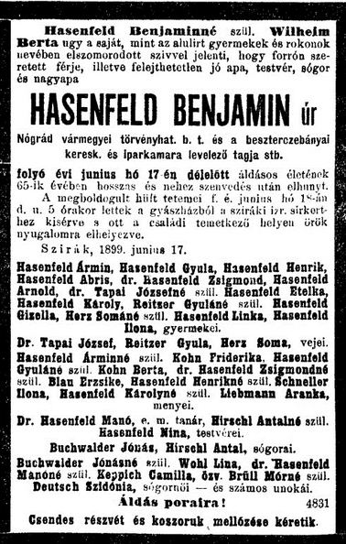

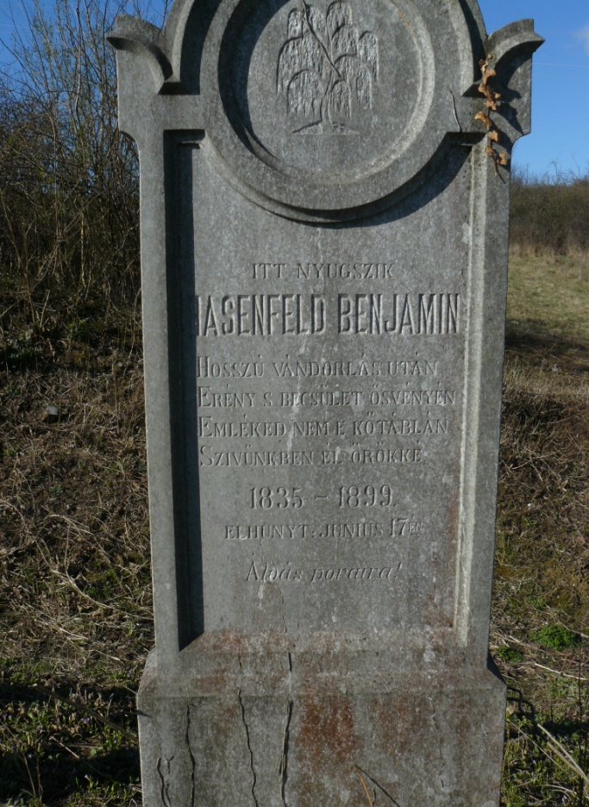

Many descendants of Benjamin Hasenfeld relocated to Budapest or further afield.
Documentation relating to many of them does not appear in the Szirák archives.

Hasenfeld Family tree at http://www.geni.com/family-tree/index/6000000023880581525

Notes for Personal Reference
Jewish Burials from the area around Szirák
Abstracted from the LDS Copies of the State death registers for Szirák in theCounty of Nógrád. 1895-1943

Jewish entriesin theSzirák Burial Recordsbetween 1895-1908
•Hungary, Civil Registration, 1801-1980, •Nógrád•Szirák
Rosenbaum Sarolta 86 nee Kuszner 10 Dec 1896
Hasenfeld Adolf 24 son of Benjamin & Karolin (nb Karolin =Lina) 09 Mar 1898
Schusztek Janette 18 dtr of Vilmos 28 Jun 1898
Prosyovin Irma, 8 mo son of Adolf & Lotti nee Raab 17 Mar 1899
Weiss Gyula 18 son of Weiss Rozsa 31 Mar 1899
Hasenfeld Benjamin Gusztav, born 1834 husband of Berta nee Wilheim
son of Arnold & Eszter nee Kohn 17 Jun 1899
Lowy no name 1day son of Jakab& Ernestin nee Kohn 21 Sep 1899
Farkas Johanna 84 nee Lőw and widow of Wilheim 11 Dec 1900
Ehrenreich Lajos Dr 64 husband of Regina nee Perlhesser
son of Moses & Fani nee Fristester 18 Feb 1901
Kuszner Mor 71 husband of Julianna nee Fein,
son of Ignácz& Anna nee Ellenbogan 24 Mar 1901
Karpelesz Mark 71 husband of Rozsalia neeBrüll
son of Rabi David &Gizella nee Kohn 27 Apr 1901
Ungar Marton 4 mo son of Farkas & Johanna nee Baumohl 31 May 1901
Simon Adolf 57 husband of Rozalia nee Eisler,
son of ??acre & Erzsebet nee Heass 12 Jan 1902
Schustelk Vilmos 83 husband of Josefin nee Goldstein, son of Jozsef 18 Feb 1902
Menczelesz Miklos 11 son of Lipot& Emmanee Markusz 21 Apr 1902
Leopold Jozsefin 84 nee Klein,widow of Samuel, 13 Aug 1902
Kraus Mór 02 son of Jakab & Terez nee Soldglaus? 28 Dec 1902
Markusz Francisca 68 nee Wiener, wife of Adolf,
dtrIgnácz&Terez nee Fischer 15 Mar 1904
Guttfreund Etel 17 dtr of Abraham &Katalin nee Leopold 11 May 1904
Markusz Julianna 55 nee Grun,wife of Samuel,
dtrof Vilmos&Terez neeErdo 12 Dec 1904
Kohn Anna 72 nee Vilheim,widow of Mór 09 Aug 1905
Lengyel Adolf 52 husband of Roza neeKuszner
son of Joel &Ellouisanee Wollar 15 Aug 1905
Ungar Kalman 09 son of Jakab& Lenke nee Blumenthal 20 Aug 1905
Johnella? Marton 68 son of Salamon 23 Aug 1905
Klein Olga 13 dtrof Klein Jakab & Gizella nee Konig 03 May 1906
Ungar Helena 08 dtr of Farkas & Hani nee Baunobil? 02 July 1907
Roza Lengyel 58 nee Kuszner, wife of Adolf, dtr of Marton 05 July 1908
Gutfreund Abraham 73 husband of Katalin nee Leopold 30 Nov 1908

Jewish entries in the Szirák Burial Recordsbetween 1908-1922
•Hungary, Civil Registration, 1801-1980, •Nógrád•Szirák
Gutfreund Katalin 59 nee Leopold, wife of Abraham,
dtrSamu&Jozefin nee Klein 06 July 1909
Kalman Deutsch 45 husband of Tereznee Leopold,
Son of Jozsef & Roza nee Klein 06 Nov 1909
Muller Magdelena 88 nee Pozsonyi, wife of Lipot,
dtr of Károly & Hani nee Ueiszuer? 20 Aug 1910
HevesiMór 54 husband of Czecilie nee Plon,
son of Grozsmann Antal 19 May 1911
Braun David 86 husband of Nuszi nee Graivez,
Son of Jakab & Roza nee Friss 26 July 1911
MehrMiksa (Rabi) 40 son of Mór 17 Feb 1912
Emanuel Iren 1 mo dtr of Hugo & Szidonia nee Kohn 02 Aug 1912
Markusz Adolf 84 husband of Faninee Wiener, 21 Dec 1812
UngarVilmos 30mo son of Farkas?& Hani nee Baumel 28 Dec 1912
Schonvald Simon 75 husband of Johanna nee Weisz,
sonof Abraham & Regina nee Martig 18 Mar 1913
BettiLőw 75 nee Mandel, widow of Jozsef Henrik Lőw 05 Aug 1913
Steiner GyörgyIstván 4 mo, son of Samu & Eszter nee Sohr 05 Oct 1913
GutfreundErzsébet 15 (Headstone as BOZIKA)
dtr of Miklos & Katalin nee Kohn 27 Mar 1914
SpeilbergerIgnácz 62 husband of Terez nee Leopold,
son of Jozsef& Julianna Czeisler? 04 Feb 1914
SchvarszFrigyes 15 son of Antal & Malvina nee Biermann
died Vienna 08 Oct 1912 Death reg Szirák 03 July 1914
Konig Henrik 77 19 Oct 1914
KelluerErzsébet 12days dtr of Adolf & Vilma nee Gutfreund 12 Dec 1914
Orlisy?Borbála 85 wife of Henrik, dtr of Abraham Schau 13 Apr 1915
Wiener Nathan 73 husband of Muller Betti,
son of Ignacz &Terez nee Fischer 07 Apr 1916
Frank Miksa 74 husband of Kelluers Fani,
son of Jakab & Betti nee Glabler 07 Oct 1916
Berger Jakab 71 husband ofKatalin nee Hessinger, son of Salamon 24 Dec 1916
Berger Jeno 40 husband ofCzeczlia nee Schinsflek?
sonof Marton& Anna nee Lederer 14 Jan 1917
Valli? Abraham 61 son of Abraham Lorincz and Maria nee Kohn 29 Jan 1917
MarkuszVilmos 31 son of Samuel & Johanna nee Grun 08 Oct 1915
Death regSzirák 21 Sep 1917
MarkuszMiksa 51 husband of Francsiska nee Osztreicher,
son Adolf &Fani nee Hieuer 17 Sep 1917
Wiener Erzsébet 08 dtr of Ferencz & Roza nee Lusztig 09 Jan 1919
Markusz Samuel 82 husband of Juli nee Grun, son of Zsuzsanna? 25 May 1920

Jewish entries in the Szirák Burial Recordsbetween 1923-1943
•Hungary, Civil Registration, 1801-1980, •Nógrád•Szirák
Heinmann Julianna 89 nee Füllöpp, widow of Romann 21 Jun 1924
SchnellerHermina 70 dtr of Salamon& Cecilia nee Kohn 20 Jun 1926
Schon Julianna 86 nee Frankl, wife ofLászló,
dtr of Gideon &Johanna nee Brüll 31 Mar 1930
Simon Rozi 89 nee Eisler, widow of Adolf, 23 July 1931
Kraus Jacab 71 husband of Goldenecz Terez,
sonof David &Weisz Eleanora 13 Mar 1932
Gottlieb Maria 66 dtr of Adolf &Weisz Roza 05 Nov 1932
Menczelesz Lipót 80 husband of Emma nee Markusz 05 Mar 1933
Bernfeld Zsuzsanna 13 dtr of Géza& Margit nee Gottleib 17 Sept 1935
Gottlieb Yanka 71 nee Frisch, widow of Miksa,
Dtr of Regina nee Vitt 06 July 1938
Wiener Borbála 89 nee Muller, widow of Nathan,
Dtr of Lipót & Magda nee Pozsonyi 17 Dec 1938
Schon Jozefin 64 nee Wiener, wife of Gideon,
Dtr of Marton & Betti nee Muller 12 July1941
Blumenthal Zoltan 51 husband of Klaus Elinora,
Son of Miksa & Maria nee Grunwald 08 July 1942
What happened to some Jews from the SZIRAK area during WW2?

see http://nograd.zsidomult.hu/index.php/elveszett-koezoessegek/sziraki-jaras/szirak
A rough translation of small section of the above text coldly states that: ….
… those Jews living around the Szirák area were taken to the town of Salgótarján between 5th to 10th May 1944 and held in a ghetto within the confines of the Salgótarjáni Mining Company.
That ghetto was closed on June 13th and they were deported to Auschwitz-Birkenau.

YadVashem
Listings related to Szirák in alphabetical order of surname
Top of Form
Bottom of Form
Top of Form
Please note:
There may be more than one record for the same victim, originating from one or more sources.

Berko,Roza | 1895 | Borsodszirak, Hungary‎ | List of murdered persons
Blumenthal,Eleonora | 1889 | Szirak, Hungary‎ | List of murdered Jews | Murdered
Boskovitz,Jolan | 1896 | Ujpest, Hungary‎ | List of murdered Jews
Boskovitz,Jolan | 1896 | Ujpest, Hungary‎ | List of murdered persons
Braun,Ferentz | 1913 | Szirak, Hungary‎ | List of Hungarian lab ...
Buchwalder,Arpad | 1865 | Bercel (OrdasPuszta), ‎ | List of murdered Jews ...
Buchwalder,Gyorgy | 1912 | Budapest, Hungary‎ | List of murdered Jews ...
Buchwalder,Jenni | 1883 | Szirak, Hungary‎ | List of murdered Jews | Murdered
Buchwalder,Lajos | 1863 | Szirak, Hungary‎ | List of murdered Jews | Murdered
Buchwalder,Lajos | 1863 | Szirak, Hungary‎ | List of murdered Jews ...
Buchwalder,Margit | 1879 | Szirak, Hungary‎ | List of murdered Jews | Murdered
Buchwalder,Margit | 1879 | Szirak, Hungary‎ | List of murdered Jews ...
Domann,Andor | 1910 | Szirak, Hungary‎ | List of persecuted pe ...
Elias,Marta | 1911 | Rakospalota, Hungary‎ | List of murdered Jews ...
Elias,Marta | 1911 | Rakospalota, Hungary‎ | List of murdered persons
Fleischer,Pepi | 1889 | Miskolc, Hungary‎ | Page of Testimony
Gottlieb,Endre | 1891 | Budapest, Hungary‎ | List of murdered Jews ...
Gottlieb,Endre | 1891 | Budapest, Hungary‎ | List of murdered persons
Gottlieb,Geza | 1897 | Szirak, Hungary‎ | List of murdered persons
Gottlieb,Geza | 1897 | Szirak, Hungary‎ | List of murdered persons
Hirsch,Aranka | 1897 | Hatvan, Hungary‎ | List of murdered Jews ...
Hollos,Karoly | 1868 | Lorinci, Hungary‎ | List of murdered Jews ...
Kandel,Matild | 1903 | Miskolc, ‎ | List of murdered Jews
Kemeni,Erno | 1925 | Budapest, Hungary‎ | Page of Testimony
Kemeni,Yulius | 1886 | Subotica, Yugoslavia‎ | Page of Testimony
Kende,Sara | 1891 | Hungary‎ | List of persecuted pe ...
Kiss,Janos Zsigmond | 1934 | Szirak, Hungary‎ | List of murdered Jews | Murdered
Kiss,Maria | 1937 | Szirak, Hungary‎ | List of murdered Jews | Murdered
Kiss,Verona | 1912 | Szirak, Hungary‎ | List of murdered Jews | Murdered
Klein,IbiIboia | 1909 | Debrecen, Hungary‎ | Page of Testimony
Klein,Ibolya | 1908 | Balmazújváros, Hu | List of murdered Jews
Knepler,SenderSzender | 1901 | Szirak, Hungary‎ | Page of Testimony | Murdered
Knofler,RivkaRiwka | 1903 | Szirak, Hungary‎ | Page of Testimony | Murdered
Knöpfler,Sándor |  | Szirak, Hungary‎ | List of persecuted pe ...
Koenig,Regina | 1885 | Szirak, Hungary‎ | List of murdered pe | Murdered
Konig,Imre |  | Szirak, Hungary‎ | List of persecuted pe ... | Murdered
Konig,Imre | 1908 | Szirak, Hungary‎ | List of Hungarian lab ...
Konig,Imre | 1908 | Szirak, Hungary‎ | List of Hungarian lab ...
Konig,Soma |  | Szirak, Hungary‎ | List of persecuted pe ... | Murdered
Krausz,Aranka | 1904 | Szirak, Hungary‎ | List of murdered Jews | Murdered
Krausz,Aranka | 1904 | Szirak, Hungary‎ | List of murdered Jews ...
Krausz,Etelka | 1907 | Szirak, Hungary‎ | List of murdered Jews | Murdered
Krausz,Etelka | 1918 | Szirak, Hungary‎ | List of persecuted pe ... | Murdered
Krausz,Gyorgyi | 1930 | Szirak, Hungary‎ | List of persecuted pe ... | Murdered
Krausz,Gyorgyi | 1931 | Szirak, Hungary‎ | List of murdered Jews | Murdered
Krausz,Gyorgyi | 1931 | Szirak, Hungary‎ | List of murdered pe … | Murdered
Krausz,Ignac | 1890 | Szirak, Hungary‎ | List of murdered Jews | Murdered
Krausz,Lipot | 1896 | Szirak, Hungary‎ | List of murdered Jews | Murdered
Krausz,Lipot |  | Szirak, Hungary‎ | List of persecuted pe ... | Murdered
Krausz,Lipot | 1894 | Berzel, Hungary‎ | Page of Testimony
Krausz,Margit | 1908 | Szirak, Hungary‎ | List of murdered Jews | Murdered
Krausz,Margit | 1908 | Szirak, Hungary‎ | List of murdered Jews ...
Krausz,Rozsi | 1892 | Szirak, Hungary‎ | List of murdered Jews | Murdered
Krausz,Rozsi | 1892 | Szirak, Hungary‎ | List of murdered Jews ...
Krausz,Szeren | 1894 | Szirak, Hungary‎ | List of murdered Jews | Murdered
Krausz,Tivadar | 1906 | Szirak, Hungary‎ | List of murdered Jews | Murdered
Krausz,Tivadar | 1906 | Szirak, Hungary‎ | List of murdered Jews ...
Krausz,Tivadar | 1916 | Szirak, Hungary‎ | List of Hungarian lab ...
Krausz,Verona | 1929 | Szirak, Hungary‎ | List of murdered Jews | Murdered
Krausz,Verona | 1930 | Szirak, Hungary‎ | List of persecuted pe ... | Murdered
Loewy,Ede | 1898 | Aszod, Hungary‎ | List of murdered Jews ...
Markusz,Piros | 1904 | Salgotarjan, Hungary‎ | List of murdered persons
Markusz,Piroska | 1904 | Szirak, Hungary‎ | List of murdered Jews ...
Markusz,Viola | 1908 | Salgotarjan, Hungary‎ | List of murdered persons
Markusz,Viola | 1908 | Salgotarjan, Hungary‎ | List of murdered Jews ...
May,Simon | 1875 | Sopron, Hungary‎ | List of persecuted pe ...
Quitt,Jolan | 1890 | Hungary‎ | List of persecuted pe ...
Rosner,Adolf | 1857 | Zalaegerszeg, Hungary‎ | List of ghetto inmates
Rosner,Miklos | 1896 | Szirak, Hungary‎ | List of Hungarian lab ...
Rosner,Mozes | 1857 | Zalaegerszeg, Hungary‎ | List of ghetto inmates
Rosner,Mozes Adolf | 1857 | Zalaegerszeg, Hungary‎ | List of murdered persons
Roth,MagdaDusha | 1913 | Verebejes, Czechoslovakia‎ | Page of Testimony
Rozner,Miklos | 1896 | Budapest, Hungary‎ | List of murdered Jews
Salamon,Gyorgy | 1923 | Rakospalota, Hungary‎ | List of murdered Jews
Salamon,Gyorgy | 1923 | Rakospalota, Hungary‎ | List of murdered Jews
Salamon,Mano | 1885 | Rakospalota, Hungary‎ | List of murdered Jews
Salamon,Sarolta | 1894 | Rakospalota, Hungary‎ | List of murdered Jews
Salamon,Sarolta | 1894 | Rakospalota, Hungary‎ | List of murdered Jews
Schiffer,Miklosh | 1900 | Hatvan, Hungary‎ | Page of Testimony
Schoenwald,Sarolta | 1902 | Ujpest, Hungary‎ | List of murdered Jews ...
Schoenwald,Sarolta | 1902 | Ujpest, Hungary‎ | List of murdered persons
Schon,Dezso |  | Szirak, Hungary‎ | List of persecuted pe ... | Murdered
Schvarcz,Jolan | 1908 | Borsodszirak, Hungary‎ | List of murdered persons
Schvarcz,Laszlo | 1907 | Borsodszirak, Hungary‎ | List of murdered persons
Schwarcz,Laszlo | 1907 | Borsodszirak, Hungary‎ | List of Hungarian lab ...
Schwartz,Malvin | 1899 | Nyomar, Hungary‎ | List of murdered Jews ...
Schwarz,Roza (Rosa) | 1890 | Borsodszirak, Hungary‎ | Page of Testimony
Szabo,Anna | 1906 | Pestszenterzsebet, ‎ | List of murdered Jews ...
Szabo,Katalin | 1925 | Pestszenterzsebet, ‎ | List of murdered Jews ...
Umheiser,Ilona | 1886 | Budapest, Hungary‎ | List of murdered Jews ...
Ungar,Erna |  | Szirak, Hungary‎ | Page of Testimony | Murdered
Ungar,Ferentz |  | Szirak, Hungary‎ | Page of Testimony | Murdered
Ungar,Malka | 1906 | Szirak, Hungary‎ | Page of Testimony | Murdered
Ungar,Mor |  | Szirak, Hungary‎ | List of persecuted pe ... | Murdered
Ungar,MosheMose | 1904 | Szirak, Hungary‎ | Page of Testimony | Murdered
Weiner,Sandor | 1906 | Szirak, Hungary‎ | List of murdered pe | Murdered
Weiner,Sandor | 1900 | Szirak, Hungary‎ | List of persecuted pe ... | Murdered
Weiner,Sarolta | 1905 | Szirak, Hungary‎ | List of murdered pe | Murdered
Weiner,Sarolta | 1899 | Szirak, Hungary‎ | List of persecuted pe ... | Murdered
Wiener,Ferencz | 1872 | Szirak, Hungary‎ | Page of Testimony | Murdered
Wiener,Ferencz | 1872 | Szirak, Hungary‎ | Page of Testimony
Wiener,Ferentz | 1878 | Szirak, Hungary‎ | Page of Testimony | Murdered
Wiener,Ferentz | 1878 | Szirak, Hungary‎ | Page of Testimony
Wiener,Lajos |  | Szirak, Hungary‎ | List of persecuted pe ... | Murdered
Wiener,RozaRozsi | 1885 | Szirak, Hungary‎ | Page of Testimony | Murdered
Bottom of Form

